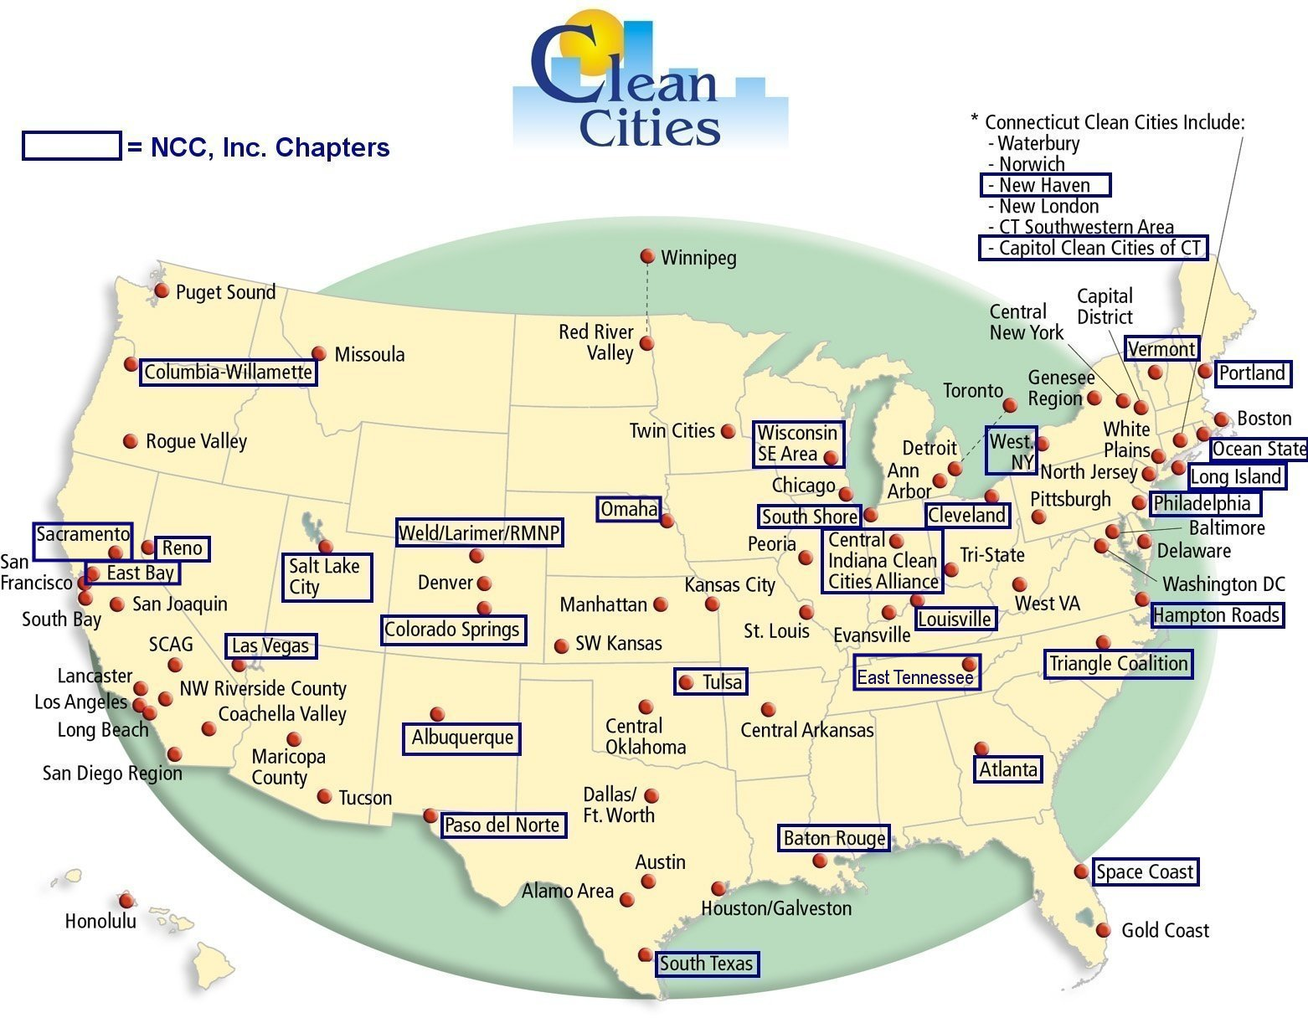
This DOE map was modified by National Clean Cities, Inc. (November 2001) to illustrate chapters of NCC, Inc.
Most recent update: 11/23/26

